Further (Final) Progress on the North Pacific Humpback Assessment
Andre E. Punt

Model diagnostics
Pages 2-26 (Figures 1-4) provide the fits to the estimates and absolute and relative abundance and the mixing proportions for the four base-case models.

Sensitivity tests
Figure 5 shows the base-case time-trajectories of total population for the four stock-structure / spatial hypothesis and the 22 sensitivity tests.

Table D.2. The sensitivity tests.
Factor | Options (Bold is the base-case) | Code
Abundance indices included | Base-case values; exclude all multistate and use Chao estimates | S1
Mixing proportions | Genetics and photo ID mark-recapture used; Genetics weighting is set to 0; photo ID mark-recapture weighting is set to 0 | S2, S3
Adult survival rate | 0.94; 0.96; 0.98 | S4, S5
Estimate time-varying survival rate | Feeding Areas; Breeding Areas; Feeding Areas but not SBC+WA or OR+CA | S6, S7
Straying rate | None; 1% straying rate | S8
Variance on survival deviation (σ_{S}) | High (6); 4; 1 | S9, S10
Mirroring time-varying survival rate | GOA mirrored to SEA+SBC; No mirrors; GOA mirrored to SEA+SBC and OR+CA mirrored to SBC+WA | S11, S12
Removals multiplier | High, Base, Low | S13, S14
Additional CV for abundance indices | Additional CV for SEA-WA, OR+CA, and GOA/NGOA; No additional CVs used | S15
Start year | 1965, 1970, 1975 | S16, S17
Weight on the index of total numbers | 1, 10 | S18
Alternative density dependence functions | Eqn B.1, Eqn B.9a, Eqn B.9ab | S19, S20
Maximum effective sample size | 50, 100, 200 | S21, S22

Comparison of maximum likelihood and bootstrap measures of uncertainty
Figure 6 compares the asymptotic and bootstrap 90% confidence intervals for total population size for the four stock-structure / spatial hypothesis while Figure 7 shows the bootstrap 90% confidence intervals for annual survival by feeding grounds.

SOSI / SOW output.
Figure 8 plots histograms the change in total abundance for the B2 stock structure hypotheses. The summary statistics are (10.7%, 96.5%, 96.1%, 109.0%) [lower 5%ile, mean, median, upper 5%ile]

Next steps
- Re-run with the updated estimates just provided by Paul Wade.
- Finalize Appendix X for IA report (model specifications)
- Finalize Appendix X+1 for IA report (a subset of the plots in this WP)
- Merge the RTMB and TMB versions of the code and provide the model specifications, code, input files and output scripts to the Secretariat for validation.

Figure 1: Stock hypothesis B1-F1
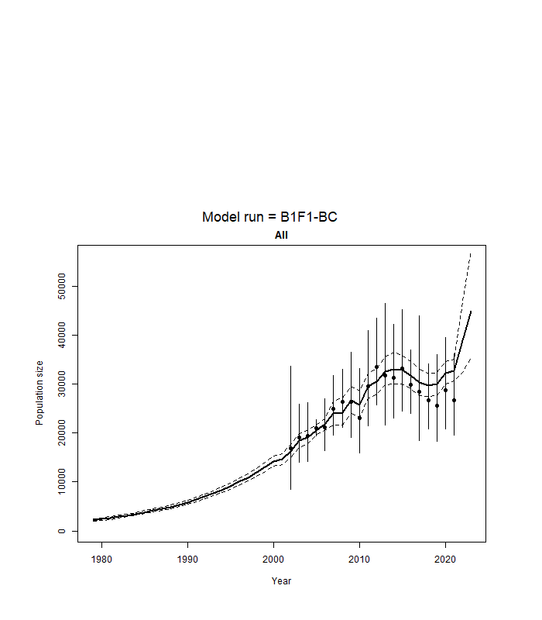
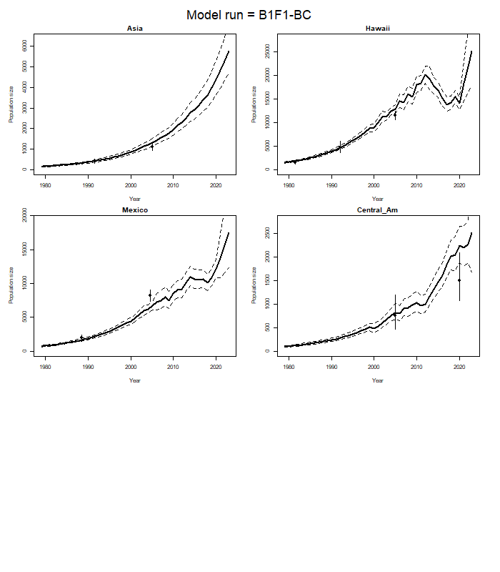
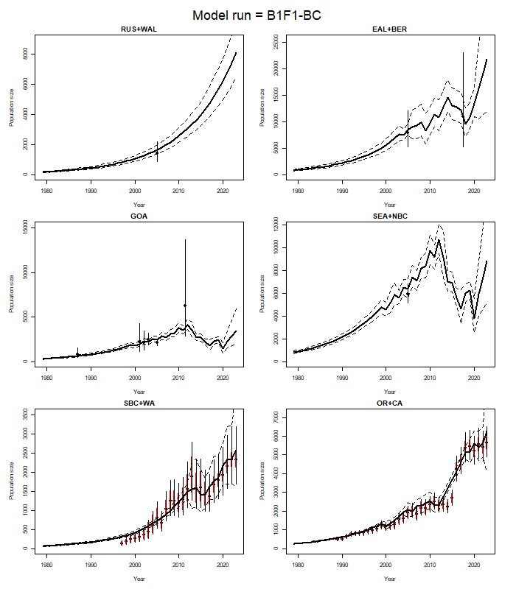
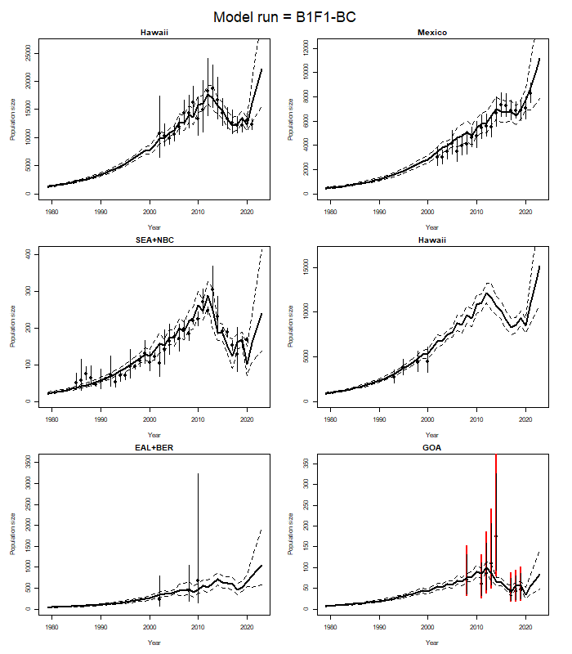
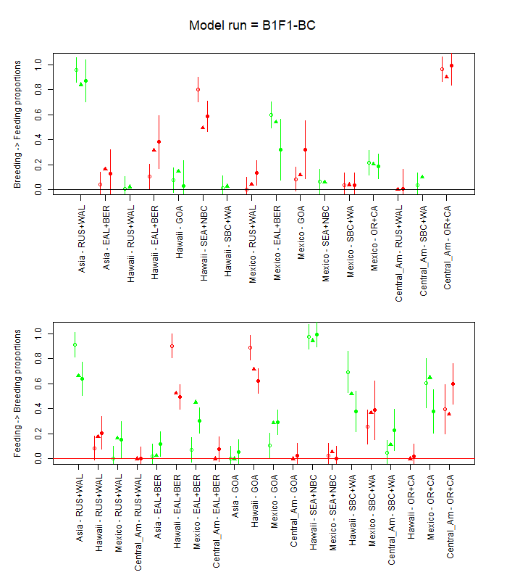
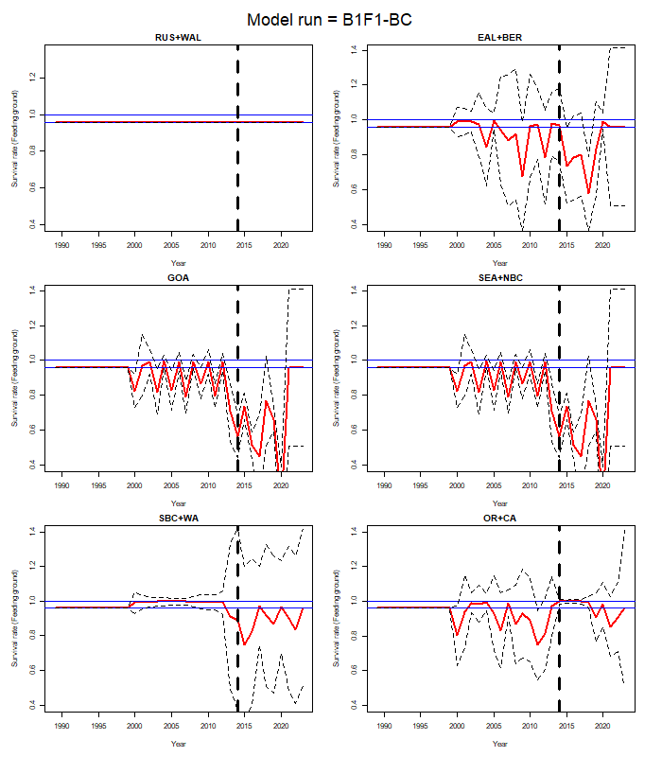

Figure 2: Stock hypothesis B1-F2
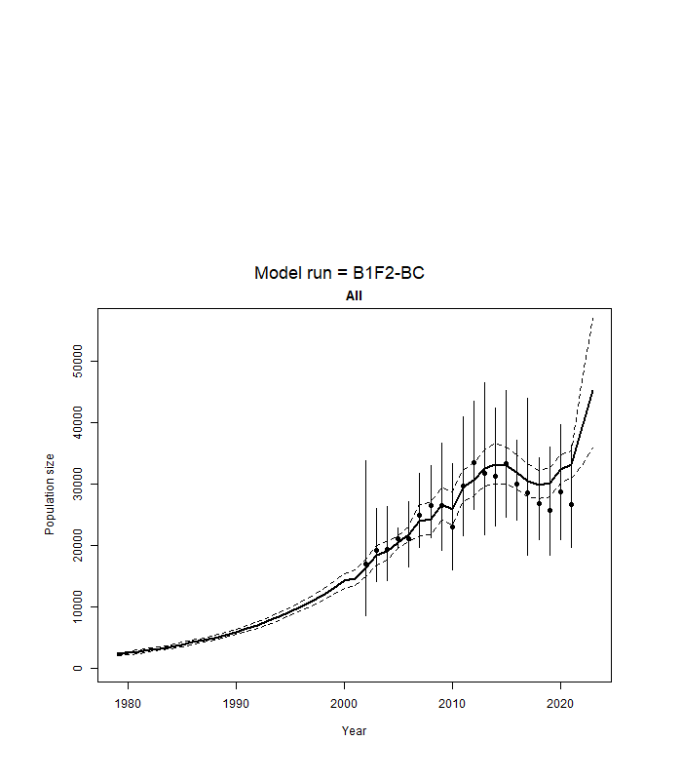
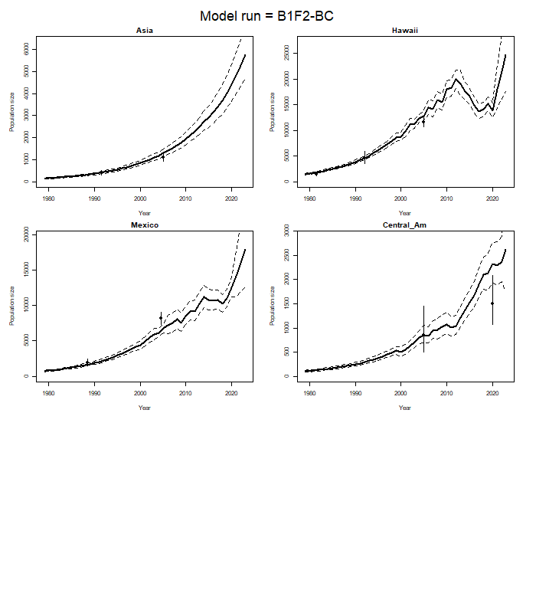
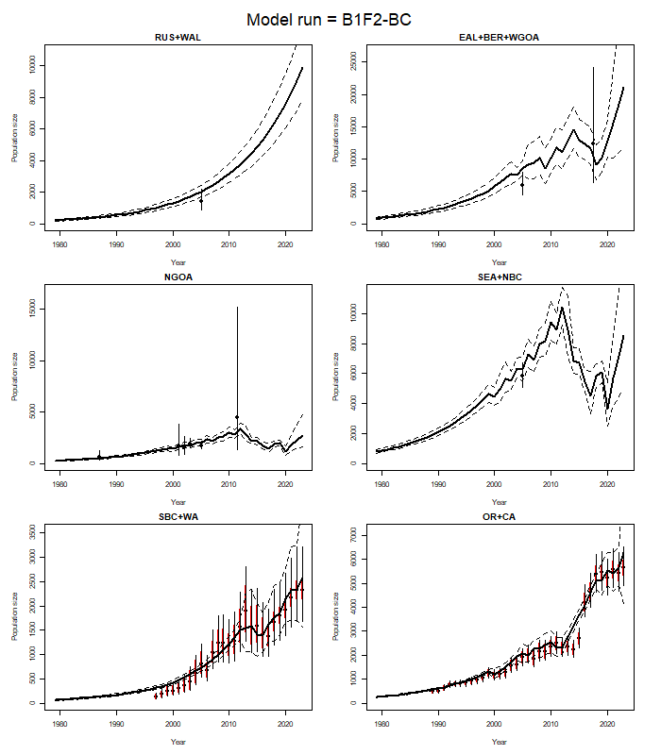
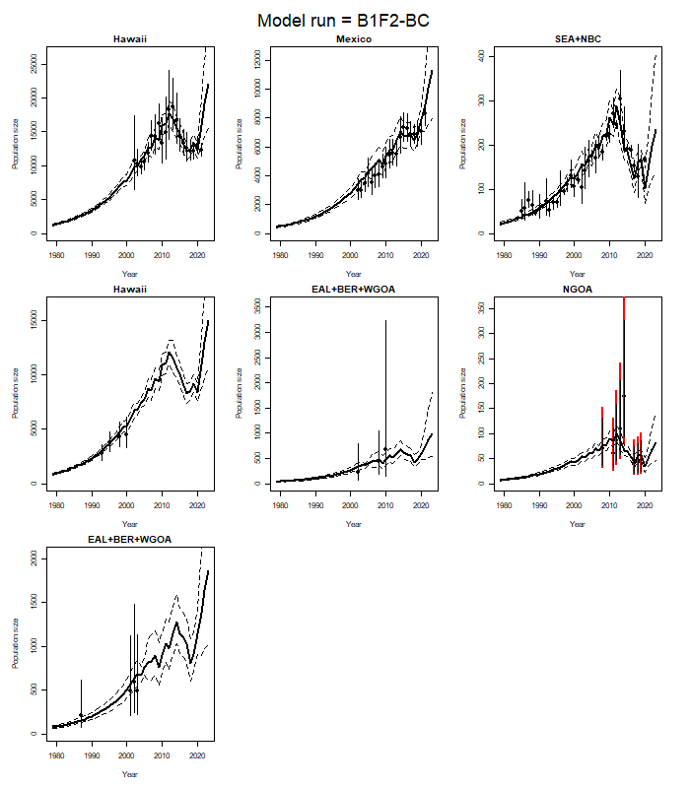

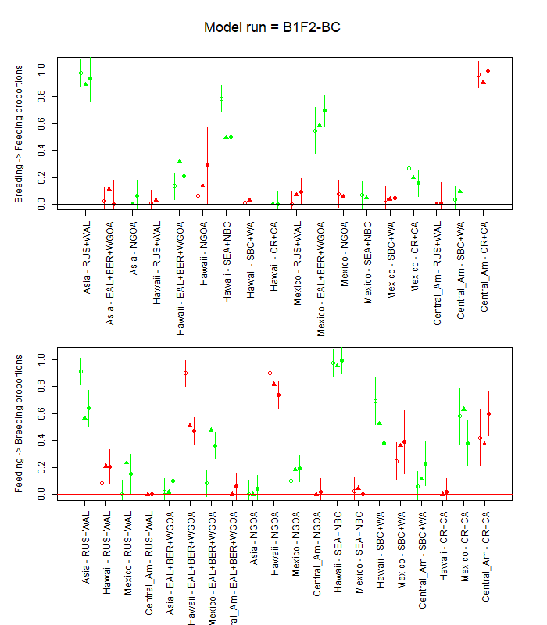
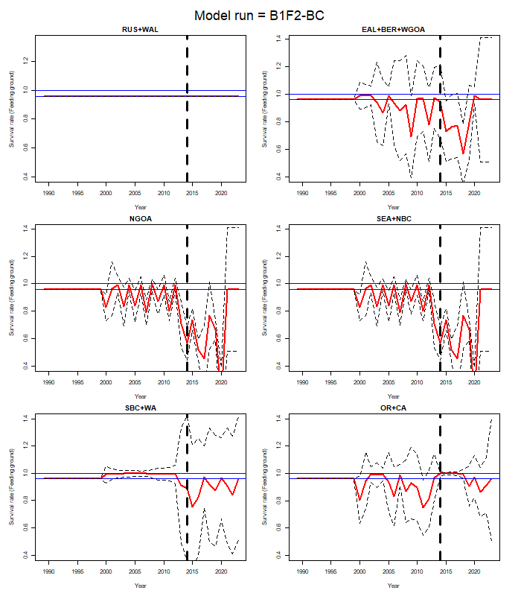
Figure 3: Stock hypothesis B2-F1
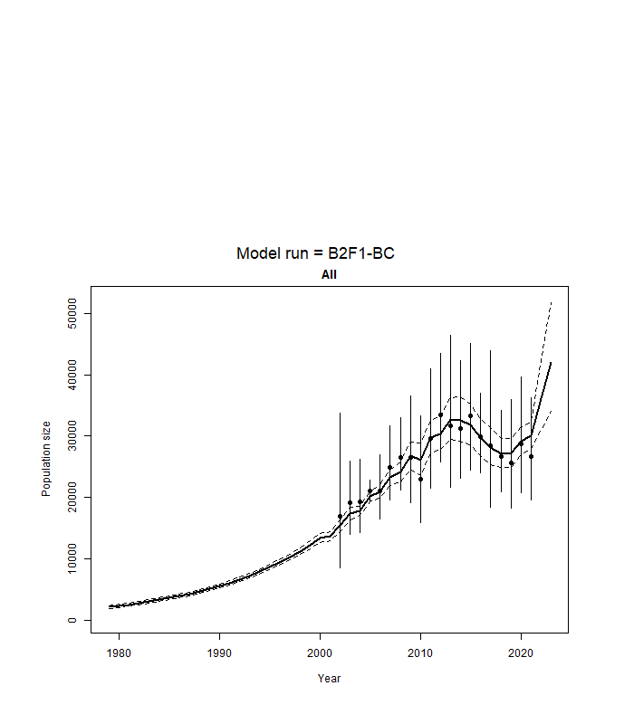
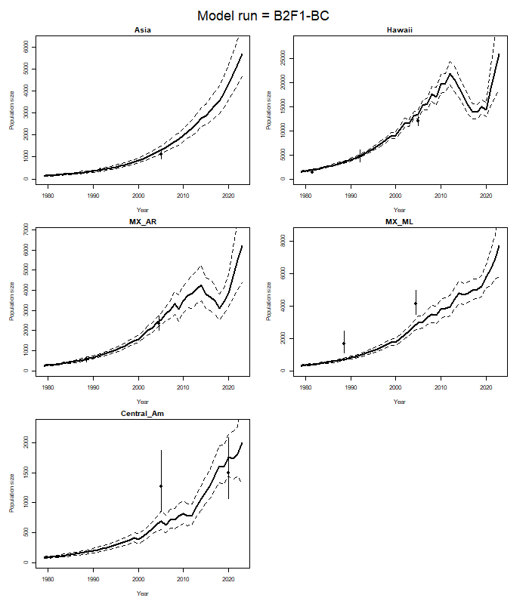
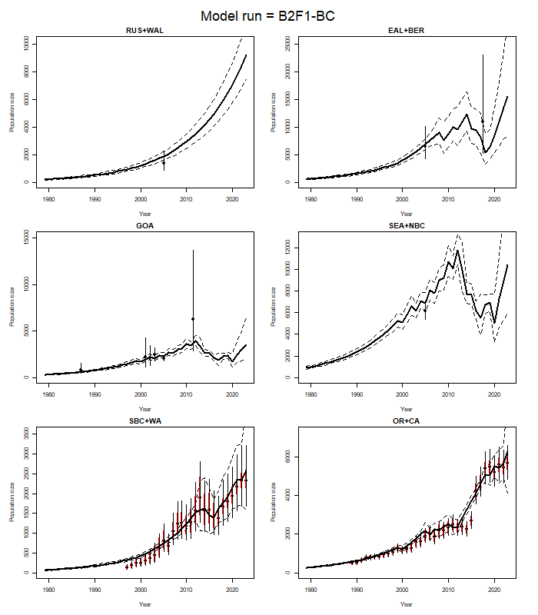
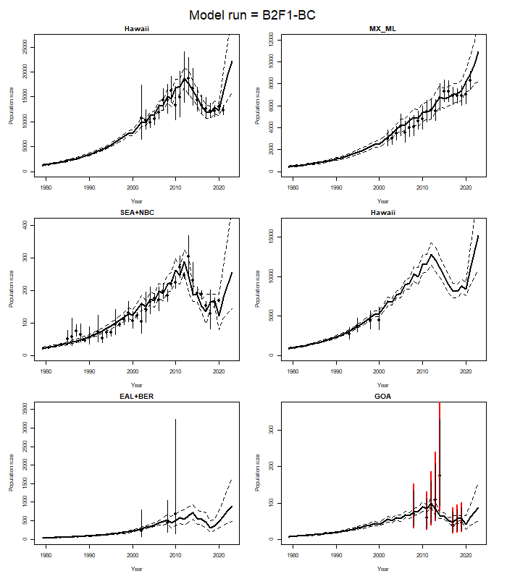
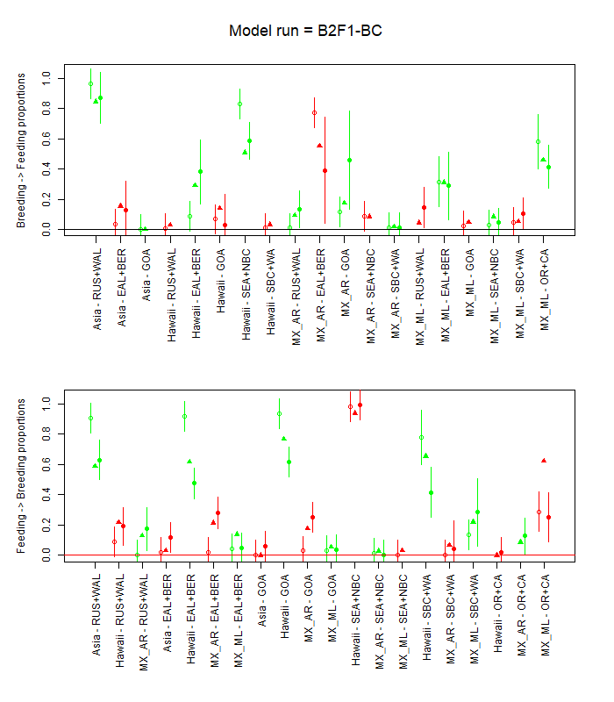
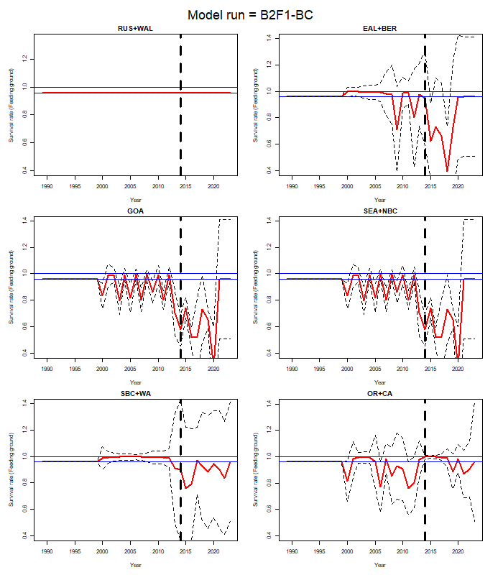

Figure 4: Stock hypothesis B2-F2
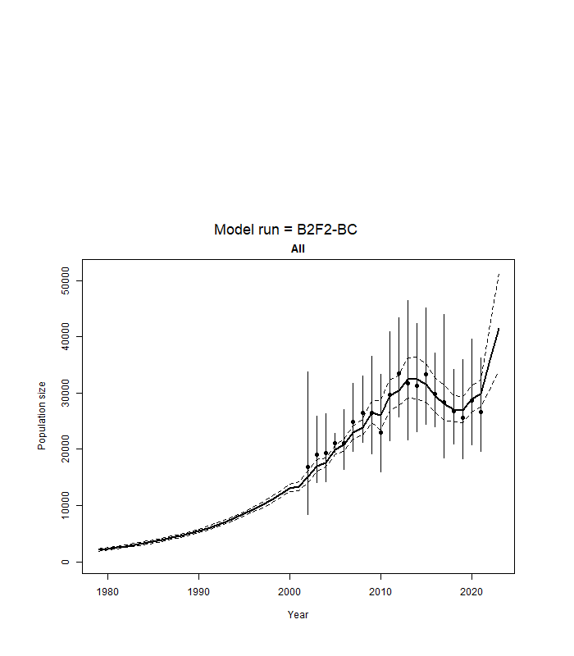
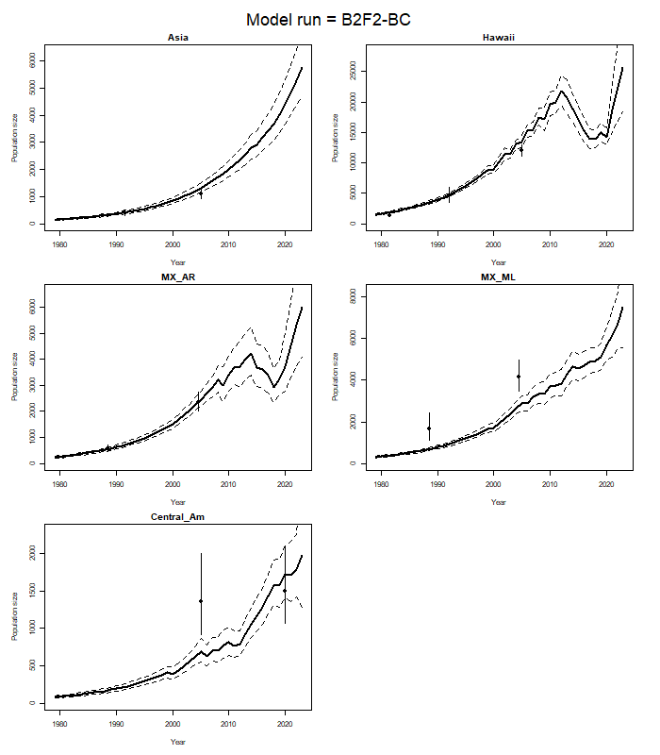
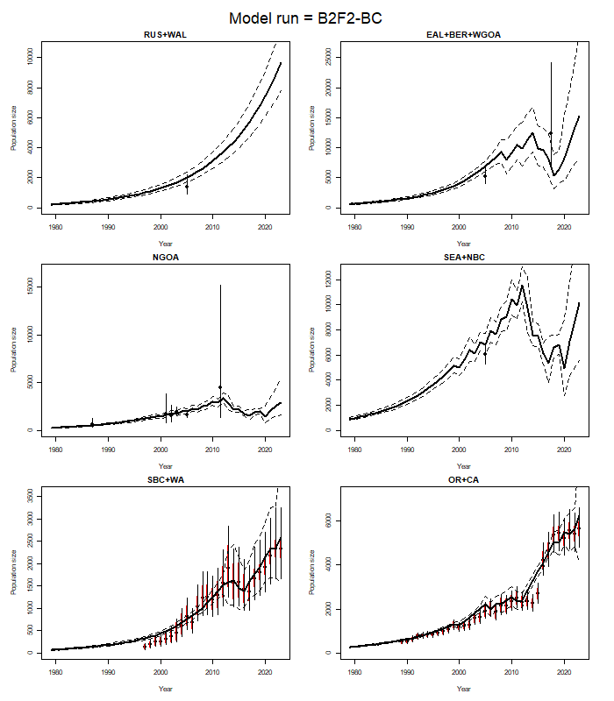
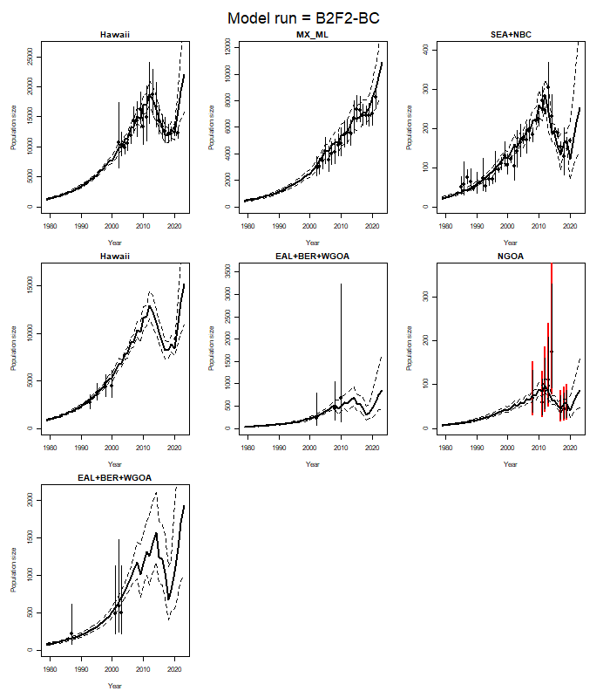
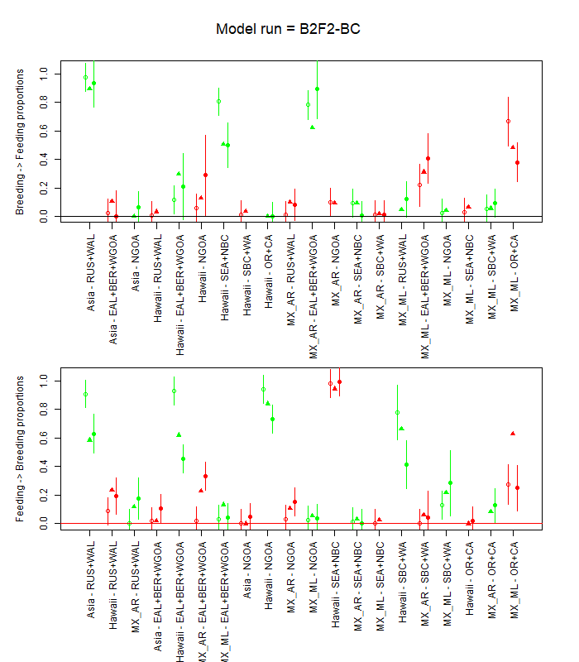
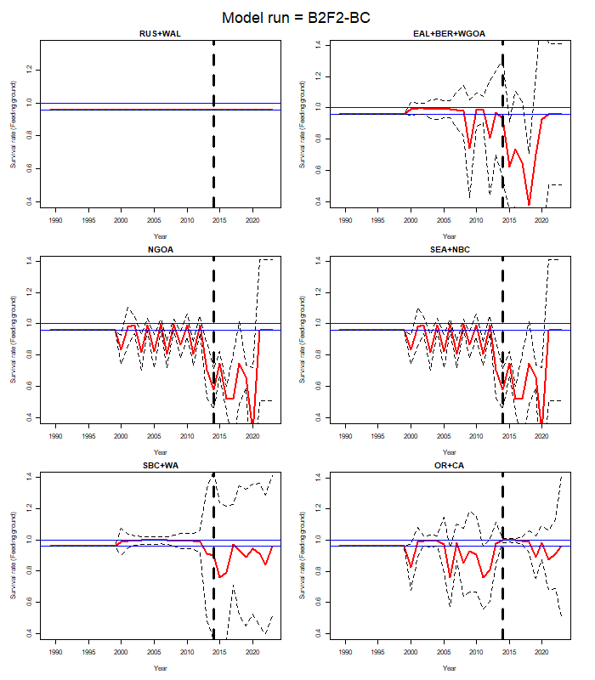

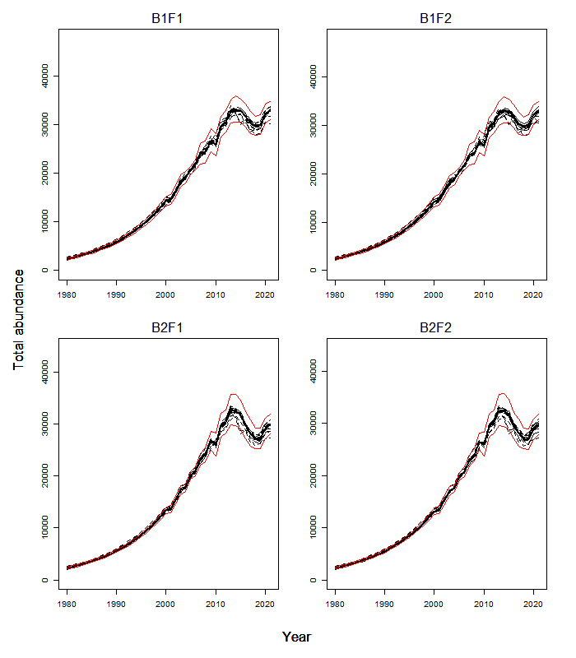
Figure 5. Sensitivity of the time-trajectories of total abundance to varying the factors in Table 1. The solid line is the base-case model and the red lines indicate 95% asymptotic confidence intervals for the base-case model.

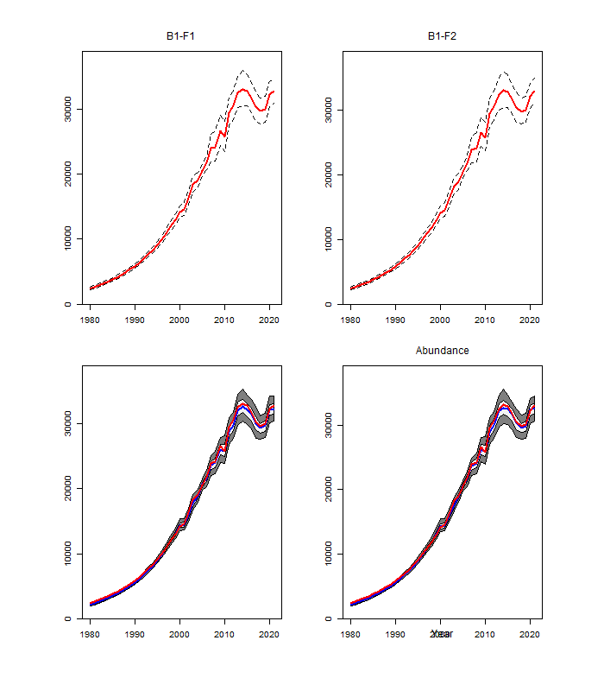Figure 6. Model estimates of absolute abundance for the entire North Pacific with their 90% confidence intervals. Results are shown in the upper panel based on the asymptotic approximation and in the lower panel based on the bootstrap procedure. The light shaded area in the lower panel covers 50% of the distribution.
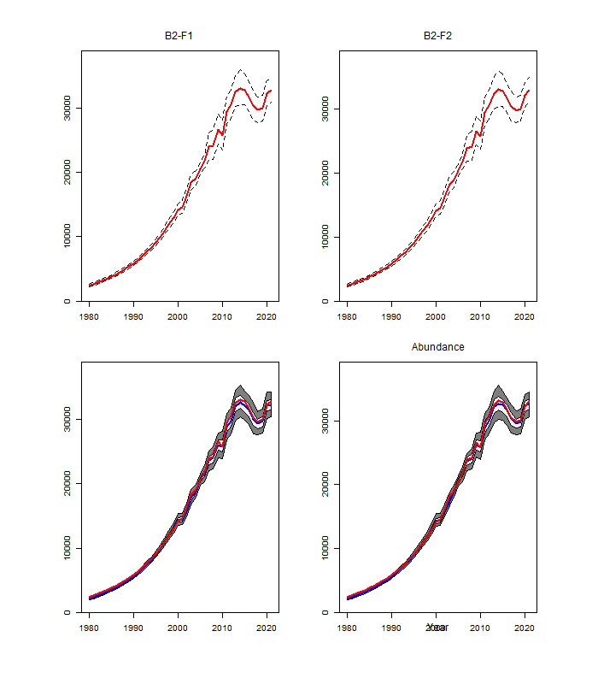
(Figure 6 Continued)
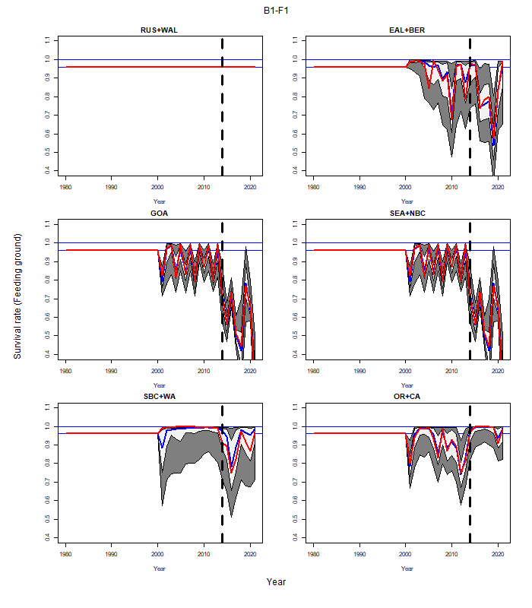
Figure 7. Time-trajectories of model estimates (with asymptotic 90% confidence intervals) of natural survival by feeding ground from the base-case version of the model for the each of the stock structure / spatial hypotheses. Note that no allowance is made for time-variation in survival for the RUS+WAL feeding ground and the survival rates for the GOA feeding ground is “mirrored” to that of the SEA+NBC feeding ground.
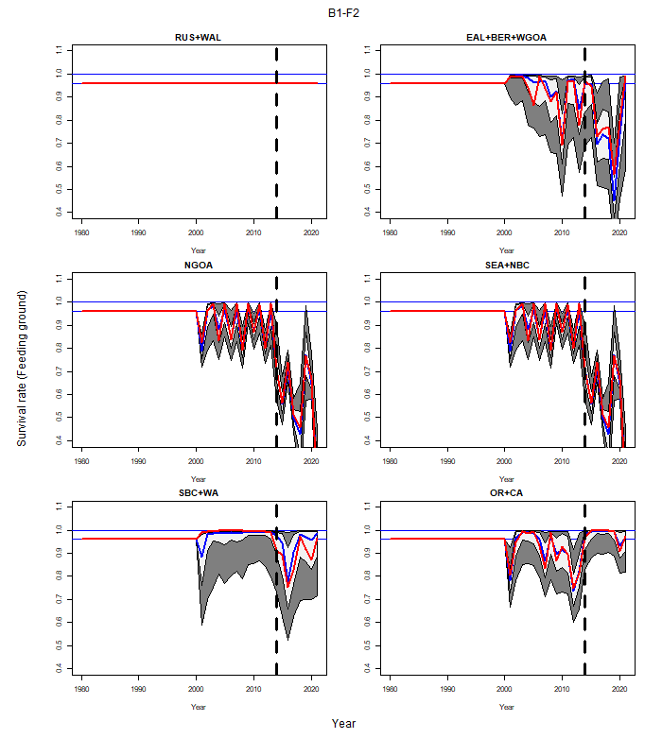(Figure 7 Continued)
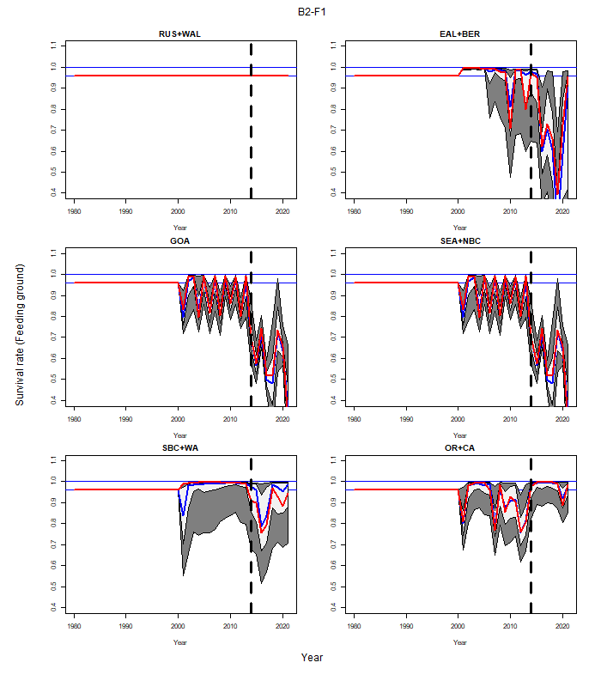(Figure 7 Continued)
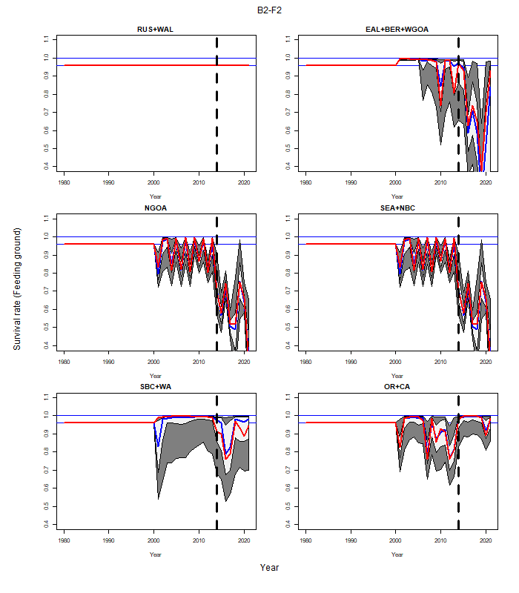(Figure 7 Continued)

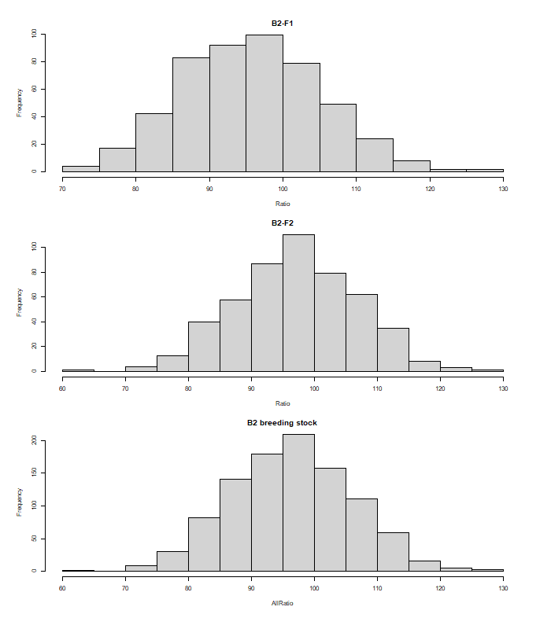
Figure 8. Histograms of the change in total abundance from 2002 to 2021 for the base-case model fits based on the B2 stock-structure hypothesis.

